Calculations

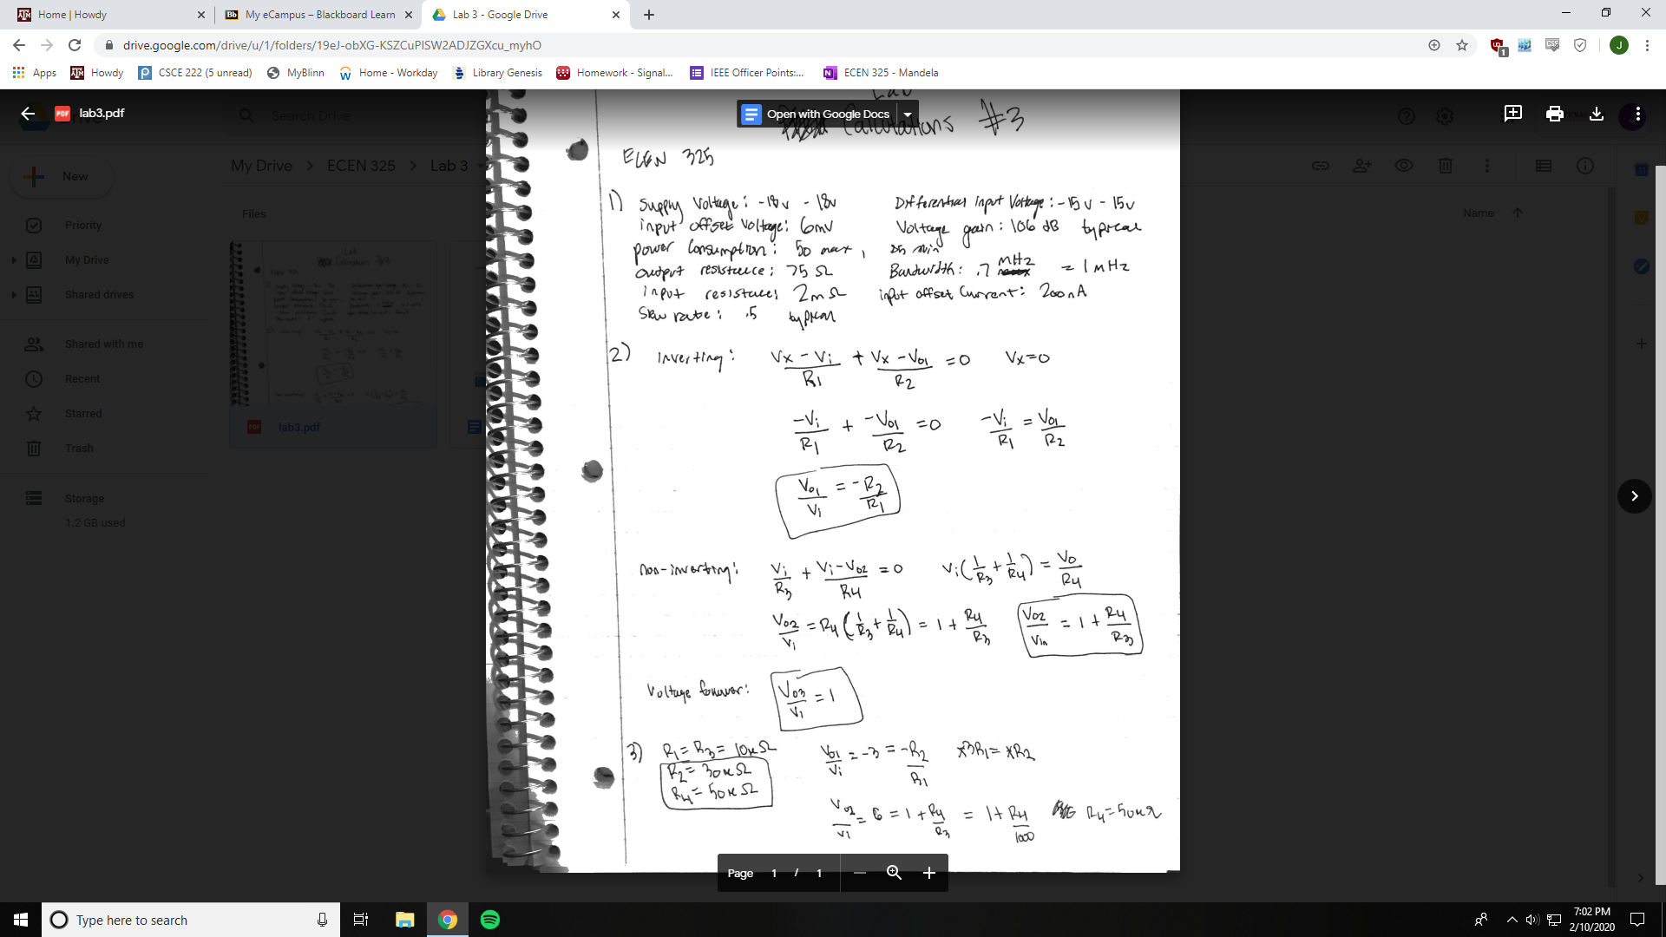

Inverting op-amp

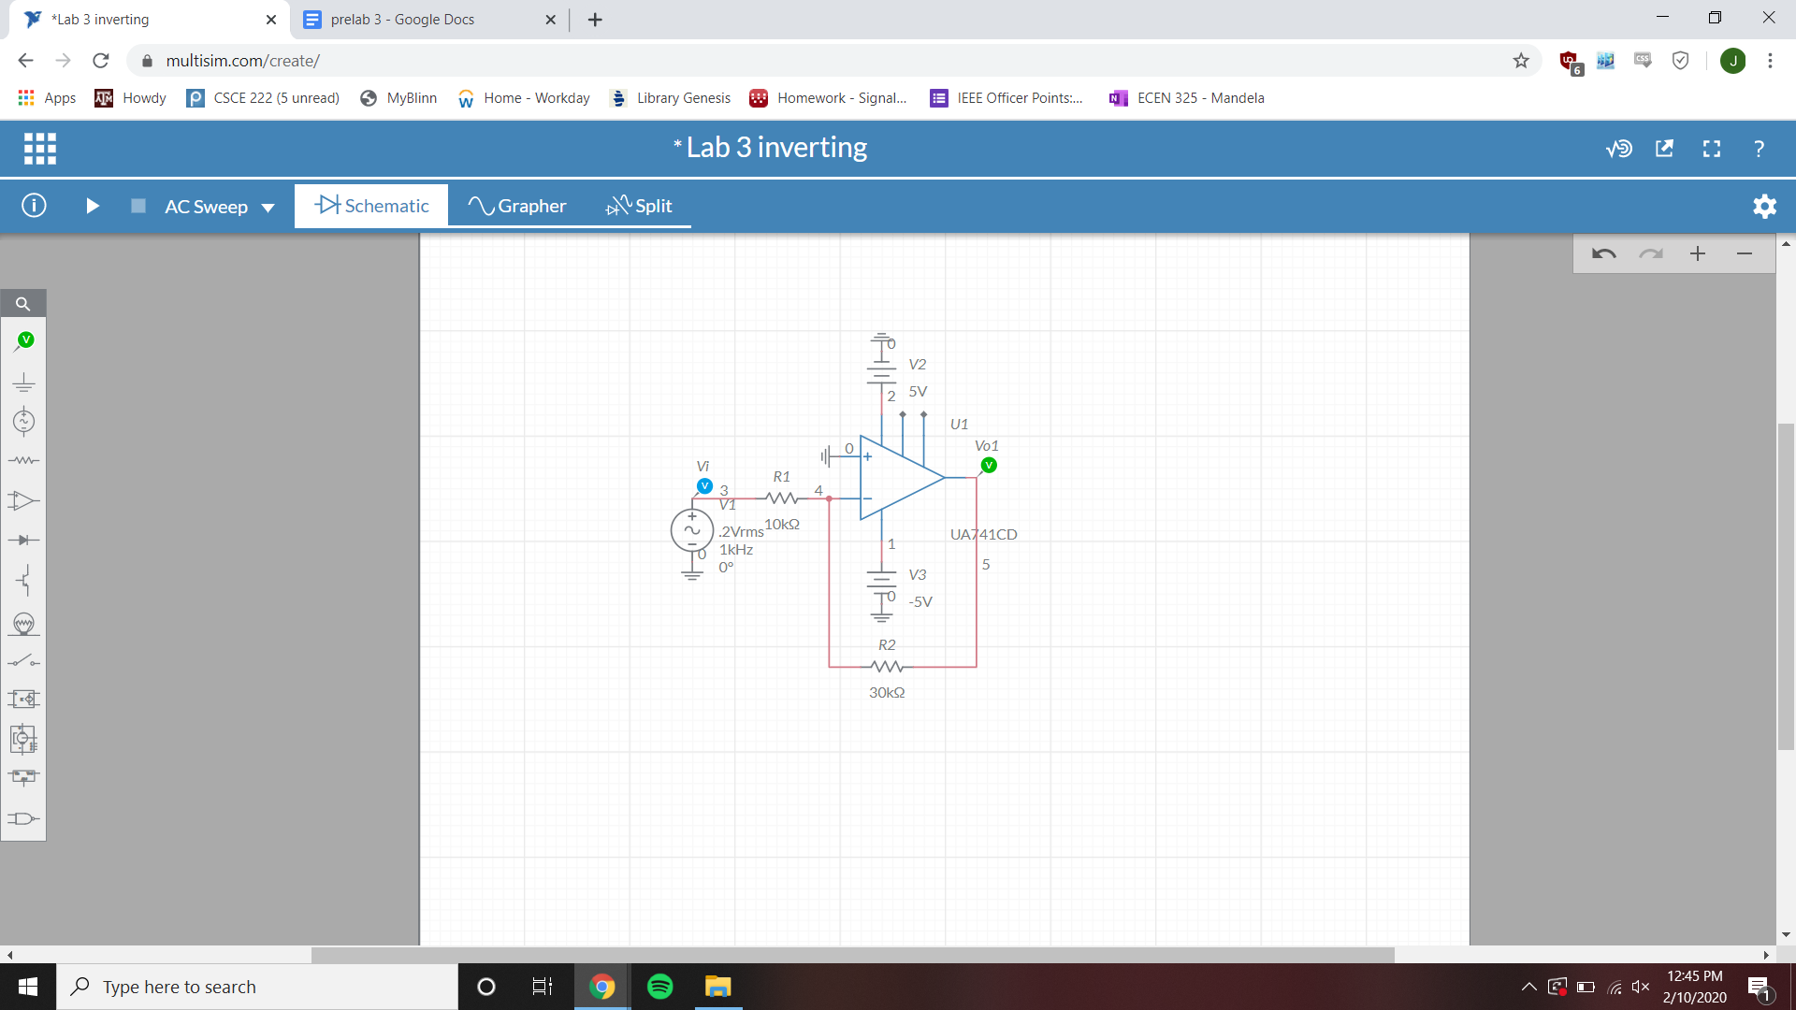

Inverting op-amp bode simulation

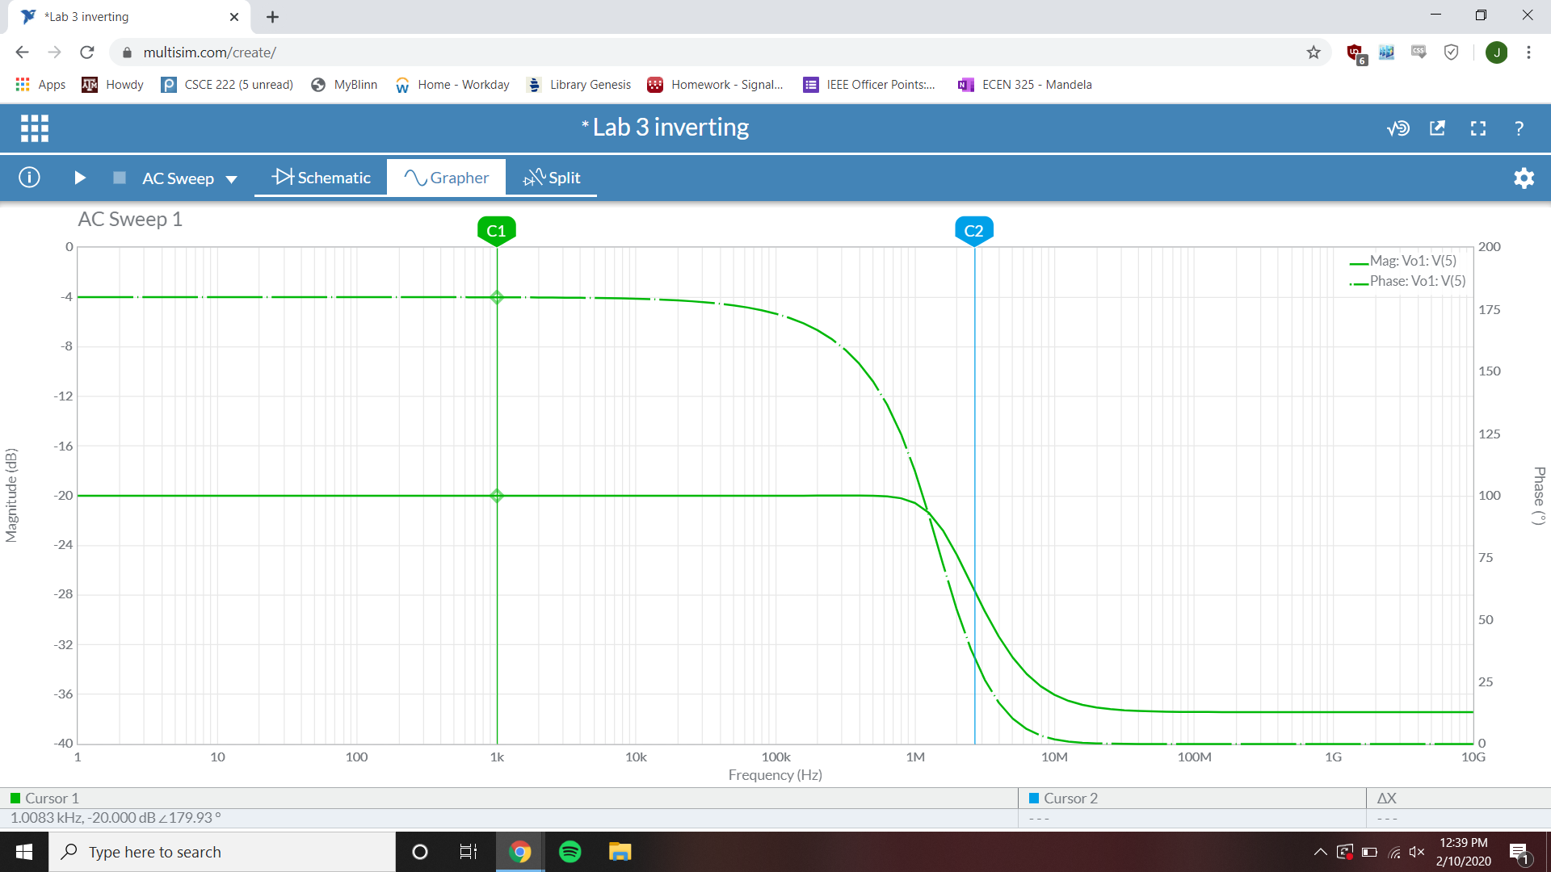

1k Hz gain = -20 dB

Inverting op-amp time-domain simulation

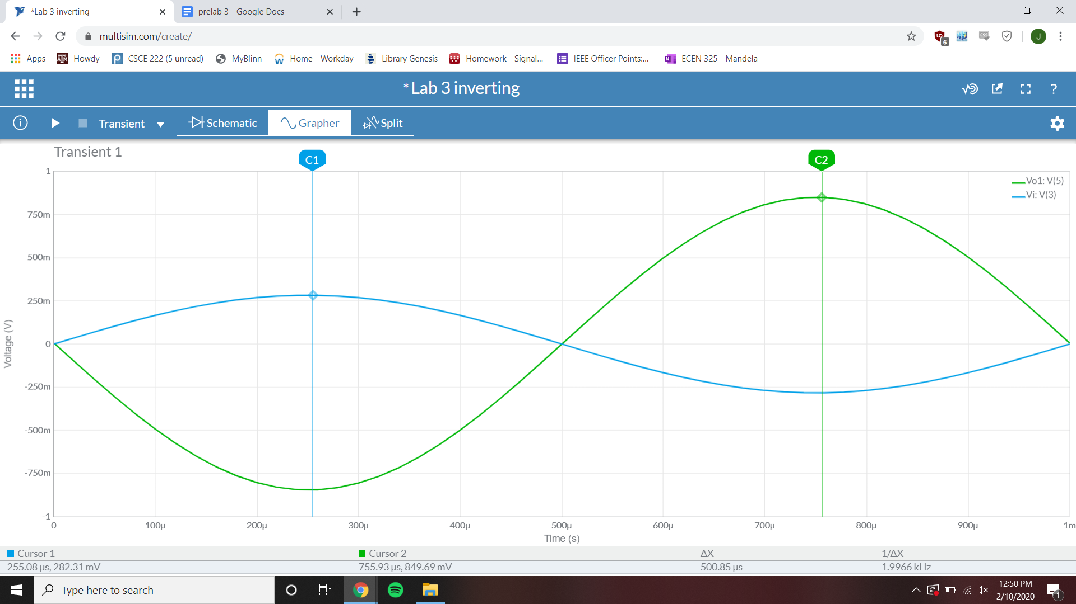

Gain = 3.009 mV/mV

Inverting op-amp parameter-sweep simulation

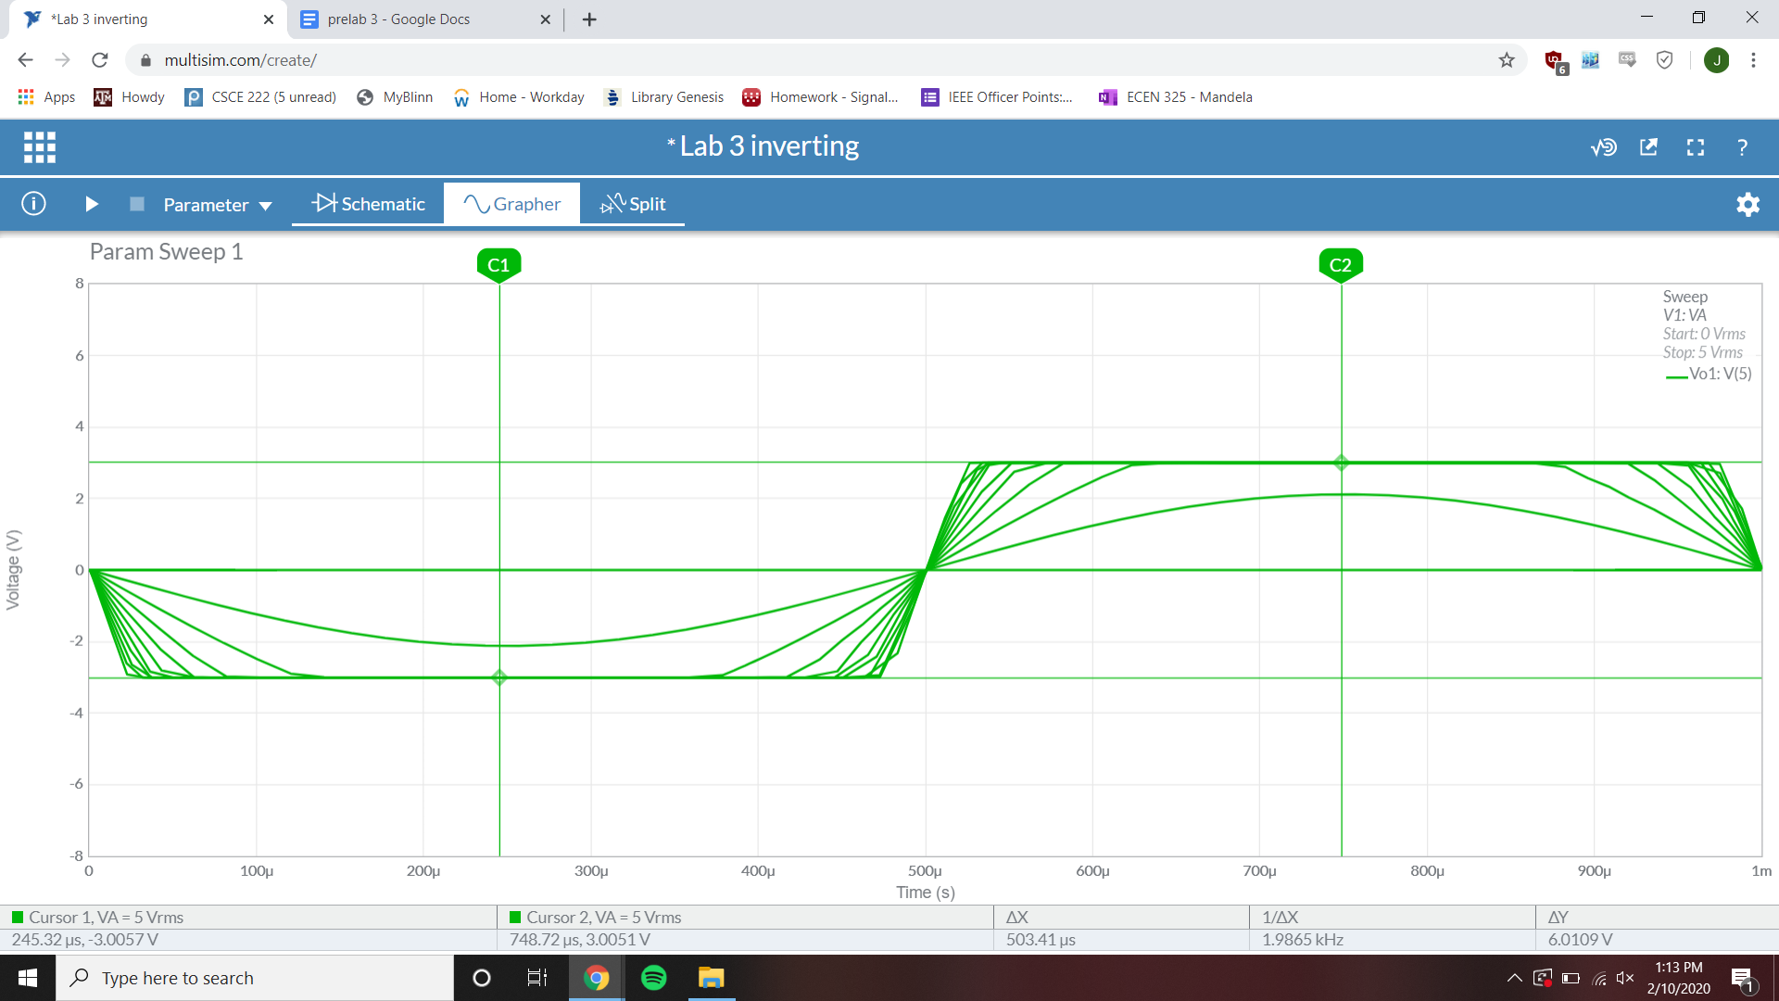

Clipping point Vi = ~1 V

Inverting op-amp fourier simulation

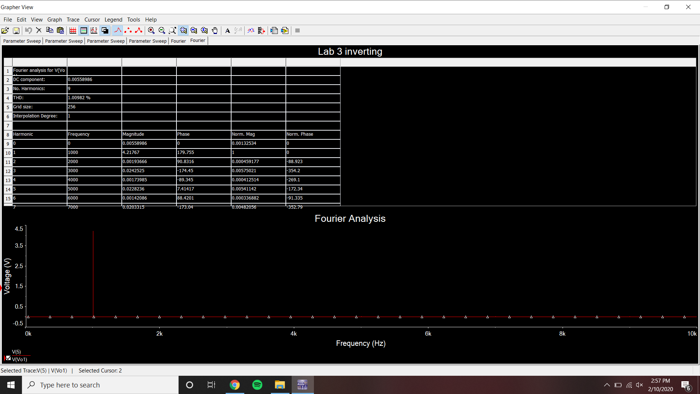

THD = 1.00982%

Non-Inverting op-amp

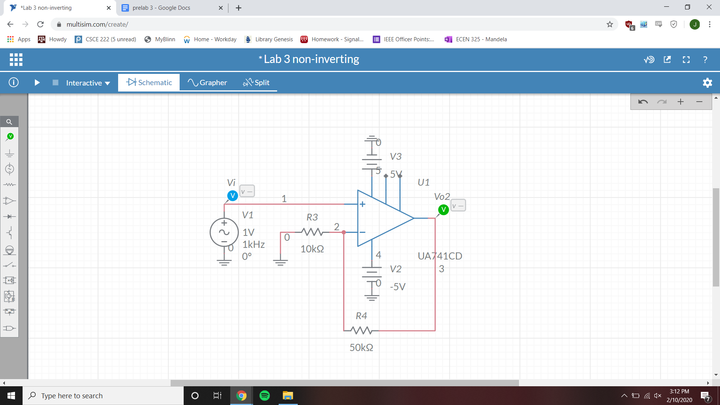

Non-Inverting op-amp bode simulation

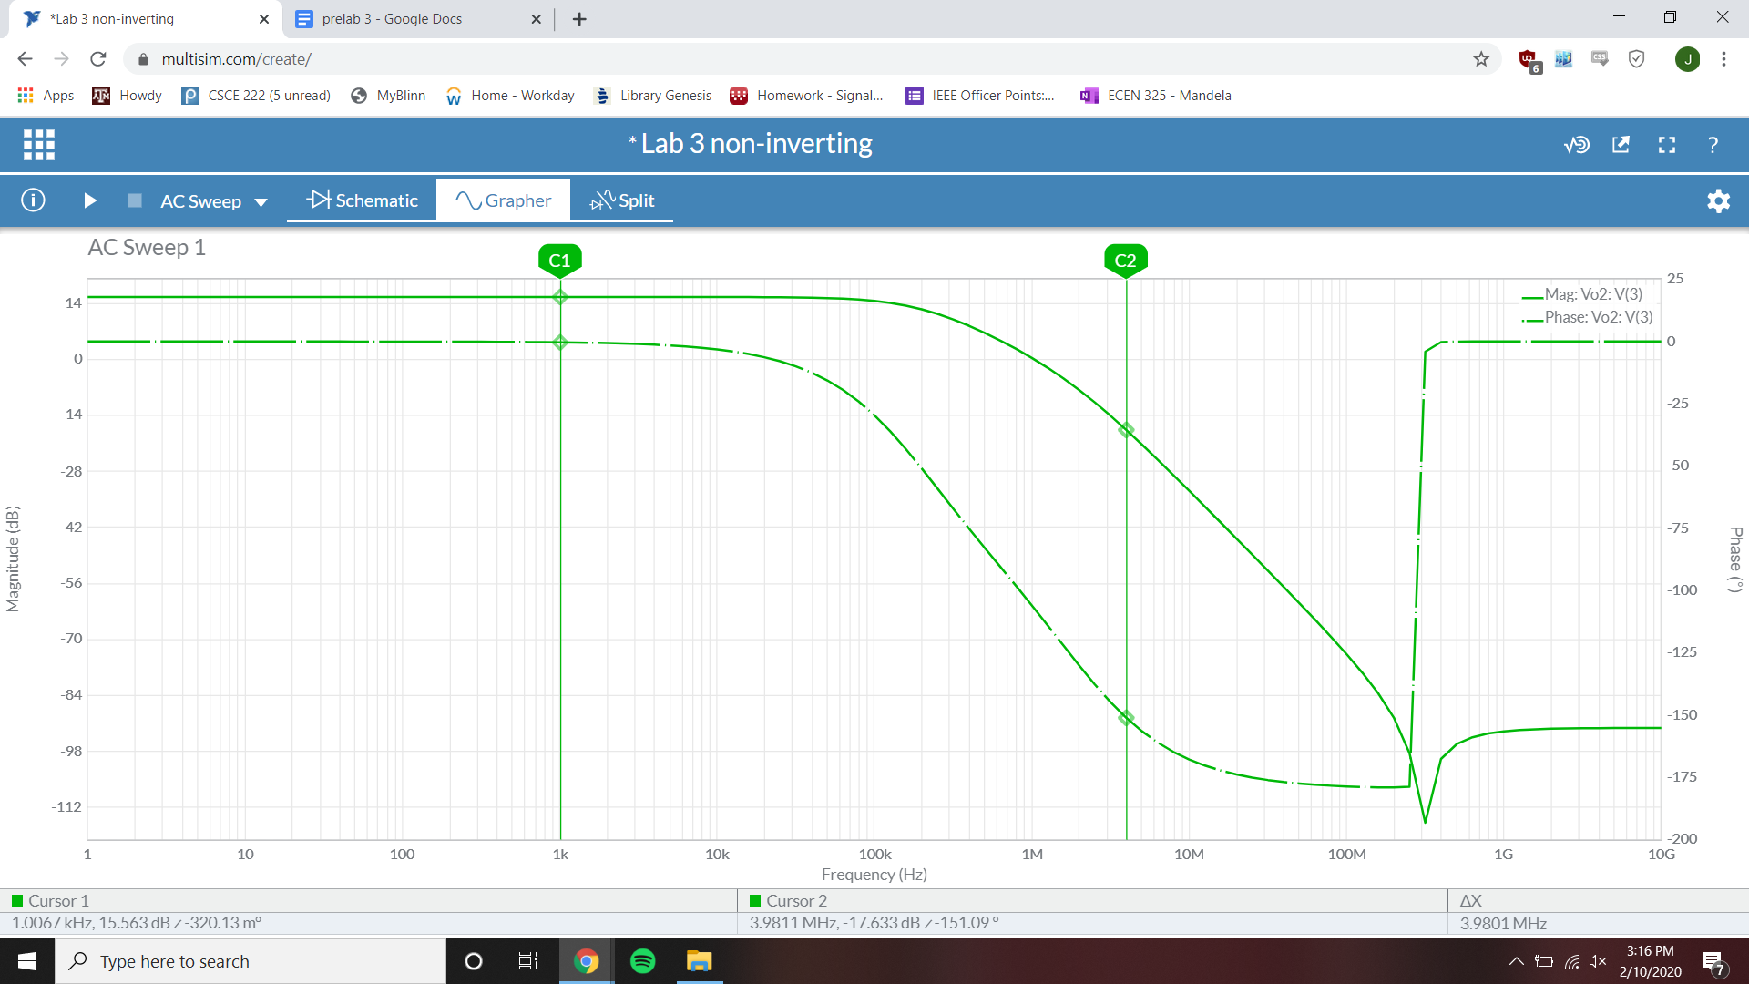

1 kHz gain = 15.563 dB

Non-Inverting op-amp time-domain simulation

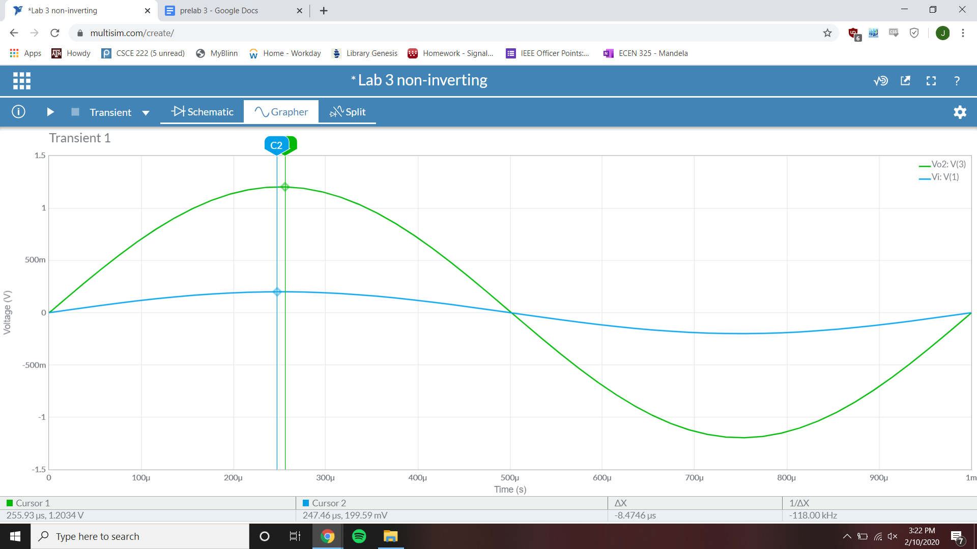

Gain = 6.029 V/V

Non-Inverting op-amp parameter-sweep simulation

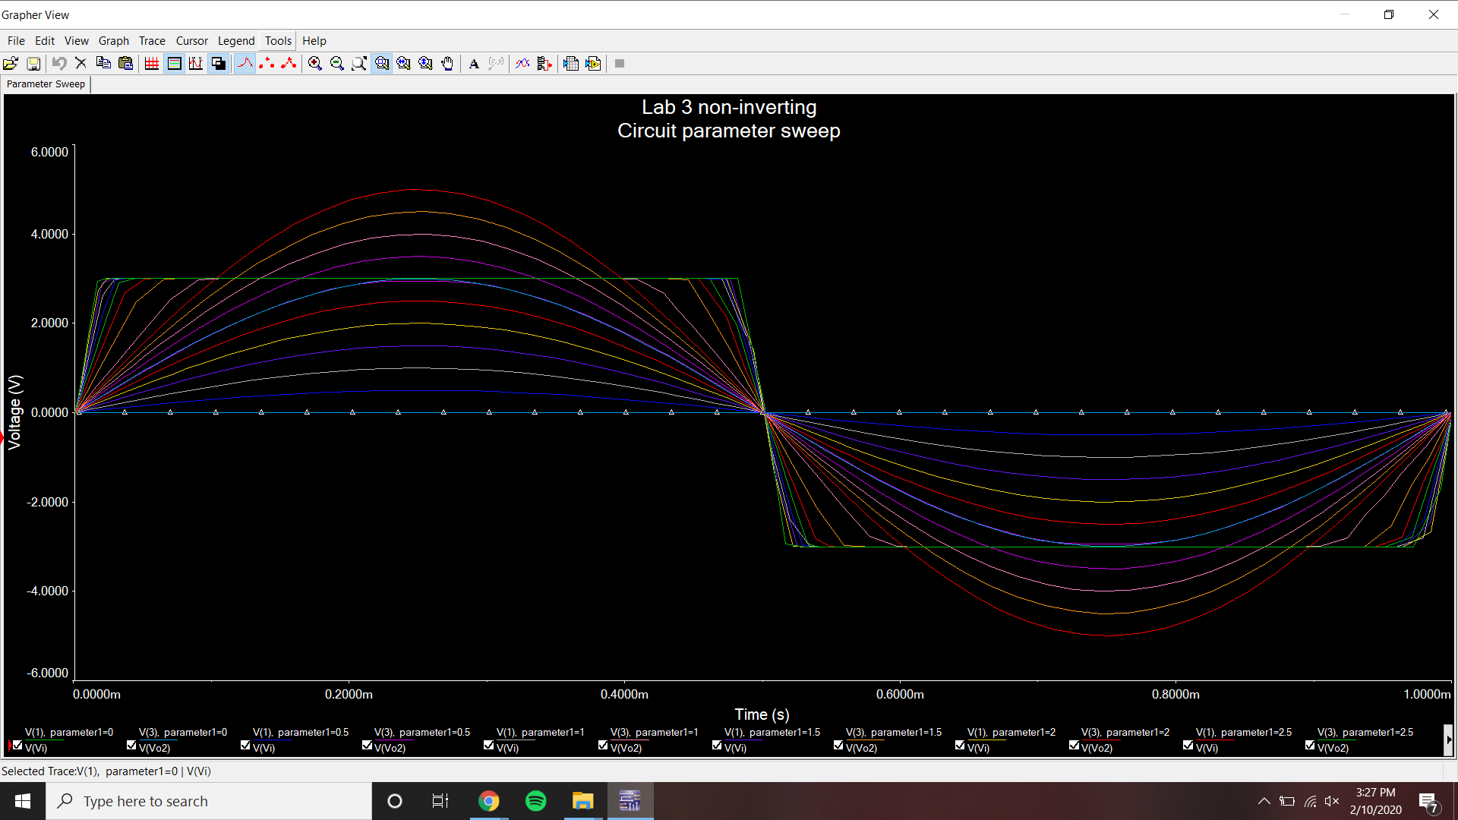

Clipping point Vi = ~1 V

Non-Inverting op-amp fourier simulation

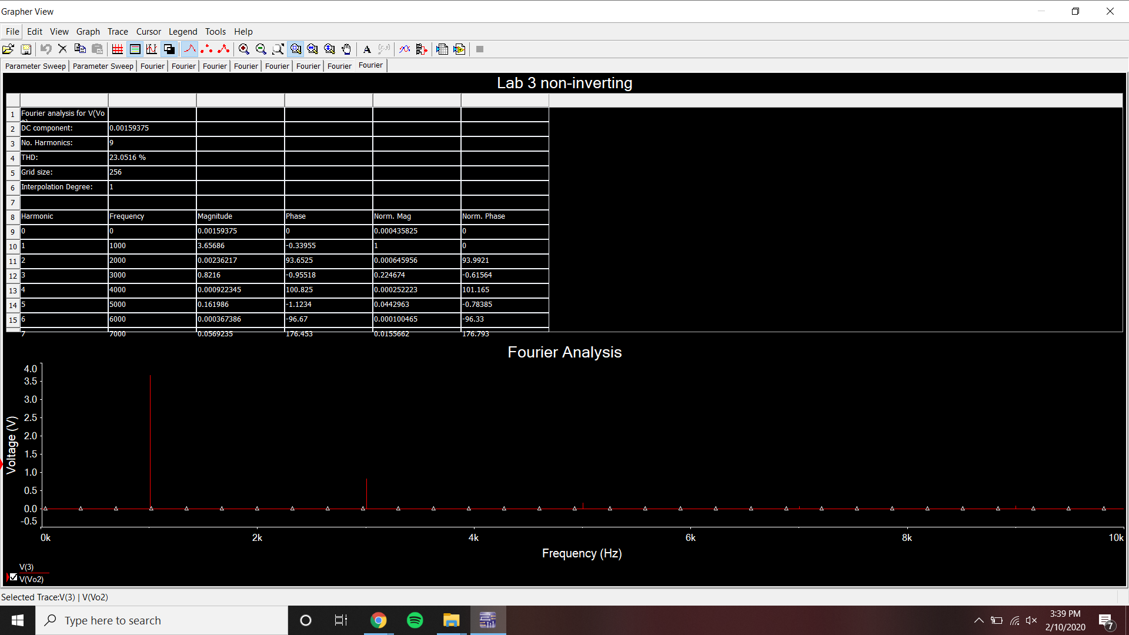

THD = 23.0516%

Voltage Follower op-amp

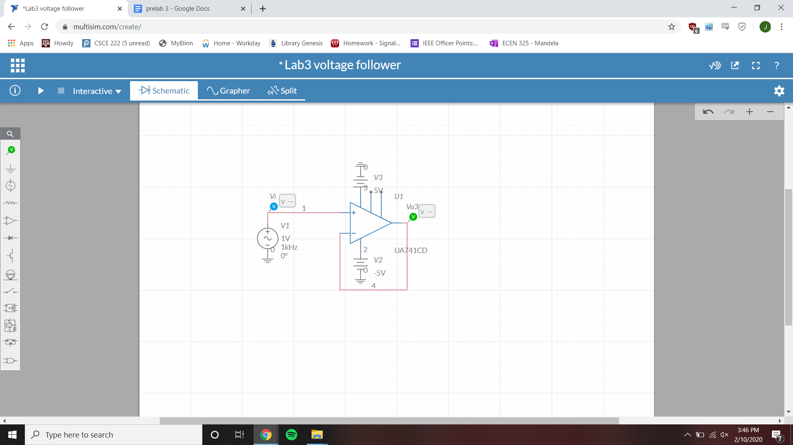

Voltage Follower op-amp bode plot

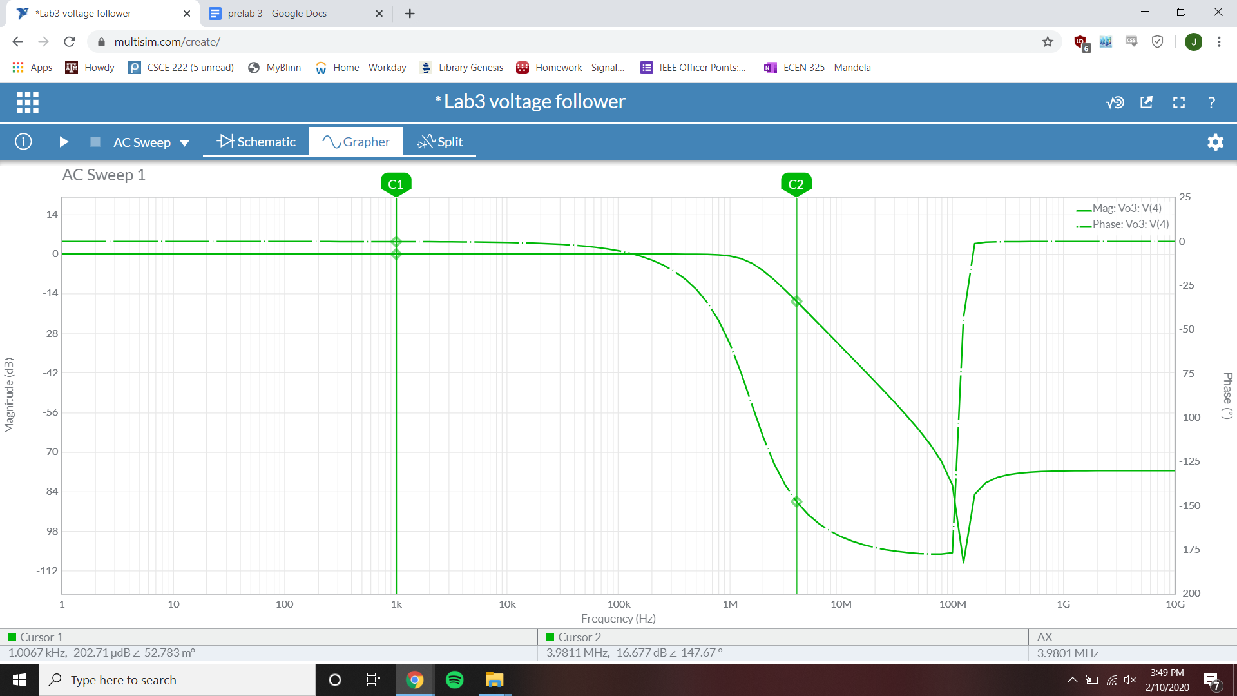

1 kHz gain = -202.71 µdB

Voltage Follower op-amp time-domain simulation

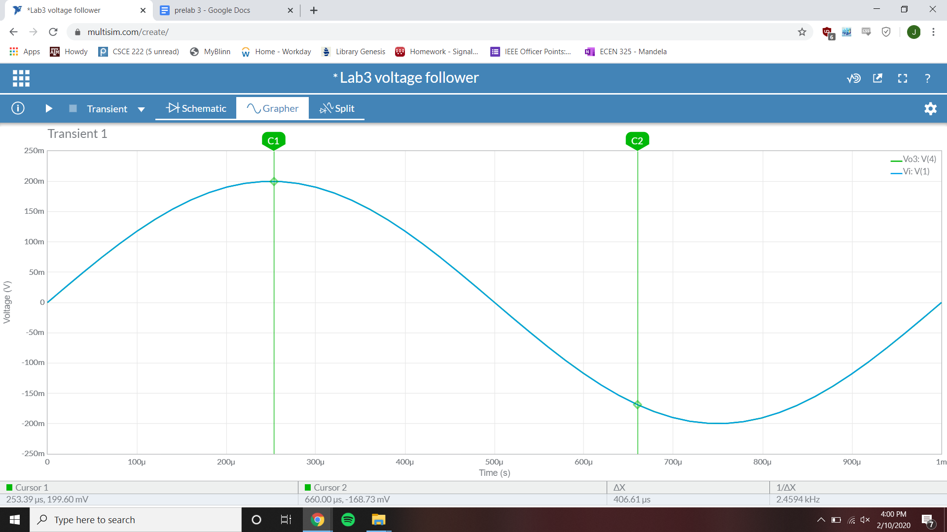

Gain = 1 V/V

Voltage Follower op-amp parameter-sweep simulation

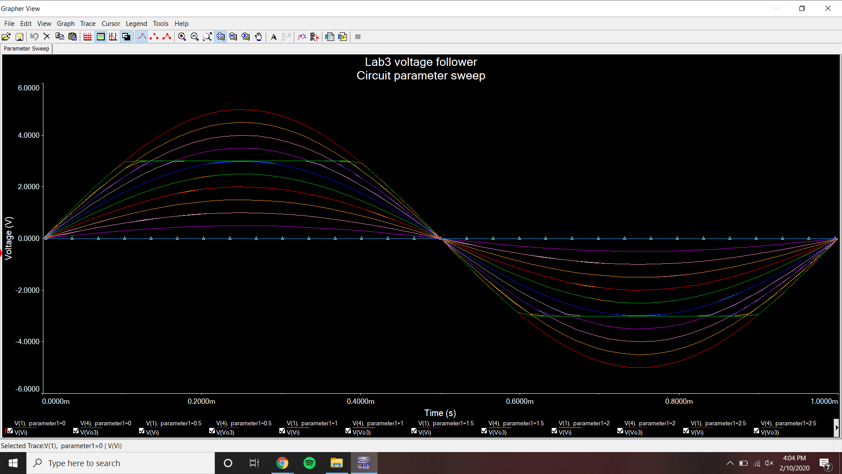

Clipping point Vi = ~3 V

Voltage Follower op-amp fourier simulation

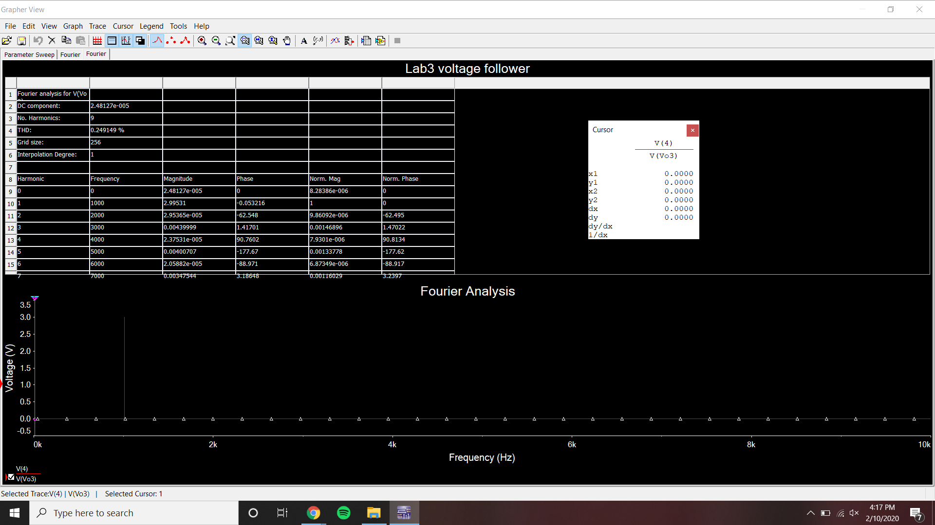

THD = .249129%